
UNIVERSITY TIMETABLE OPTIMIZATION SYSTEM
Software Engineering Project Document

By: Muhammad Hammad Shakeel
Full-Scope Use Case Analysis, Requirements Alignment, and UI Evidence

1. Introduction and Scope Alignment
UTOS is a web-based University Timetable Optimization and Management System. In the full-scope version, it is not only a class scheduling tool; it is a unified platform for class timetabling, exam timetabling, role-based access, versioning, notifications, reporting, and controlled timetable repair.
The previous project document mainly described weekly class timetable generation. This improved version aligns the document with the full SRS by adding exam scheduling, organization hierarchy, export, notifications, version comparison, audit logging, and deeper use case analysis.
Scope Area | Included in Revised Document | Reason
Class Timetabling | Yes | Core weekly timetable generation, conflicts, constraints, locking, re-optimization, publication, and reports.
Exam Timetabling | Yes | The full SRS includes exam rooms, student hierarchy, exam courses, exam placement, invigilation duties, and exam exports.
System-Wide Features | Yes | Authentication, role-based access, notifications, export, version comparison, audit logs, and user management support both modules.
Out-of-Scope Items | Documented only | Personal student timetables, full ERP, hostel, fees, attendance, and multi-campus simulation remain outside v1.0 scope.

2. Process Model Alignment
The selected development lifecycle remains the Incremental Process Model with prototyping as a supporting technique. The full SRS expands the plan from a class-only delivery into ten increments covering class, exam, system, and integration concerns.
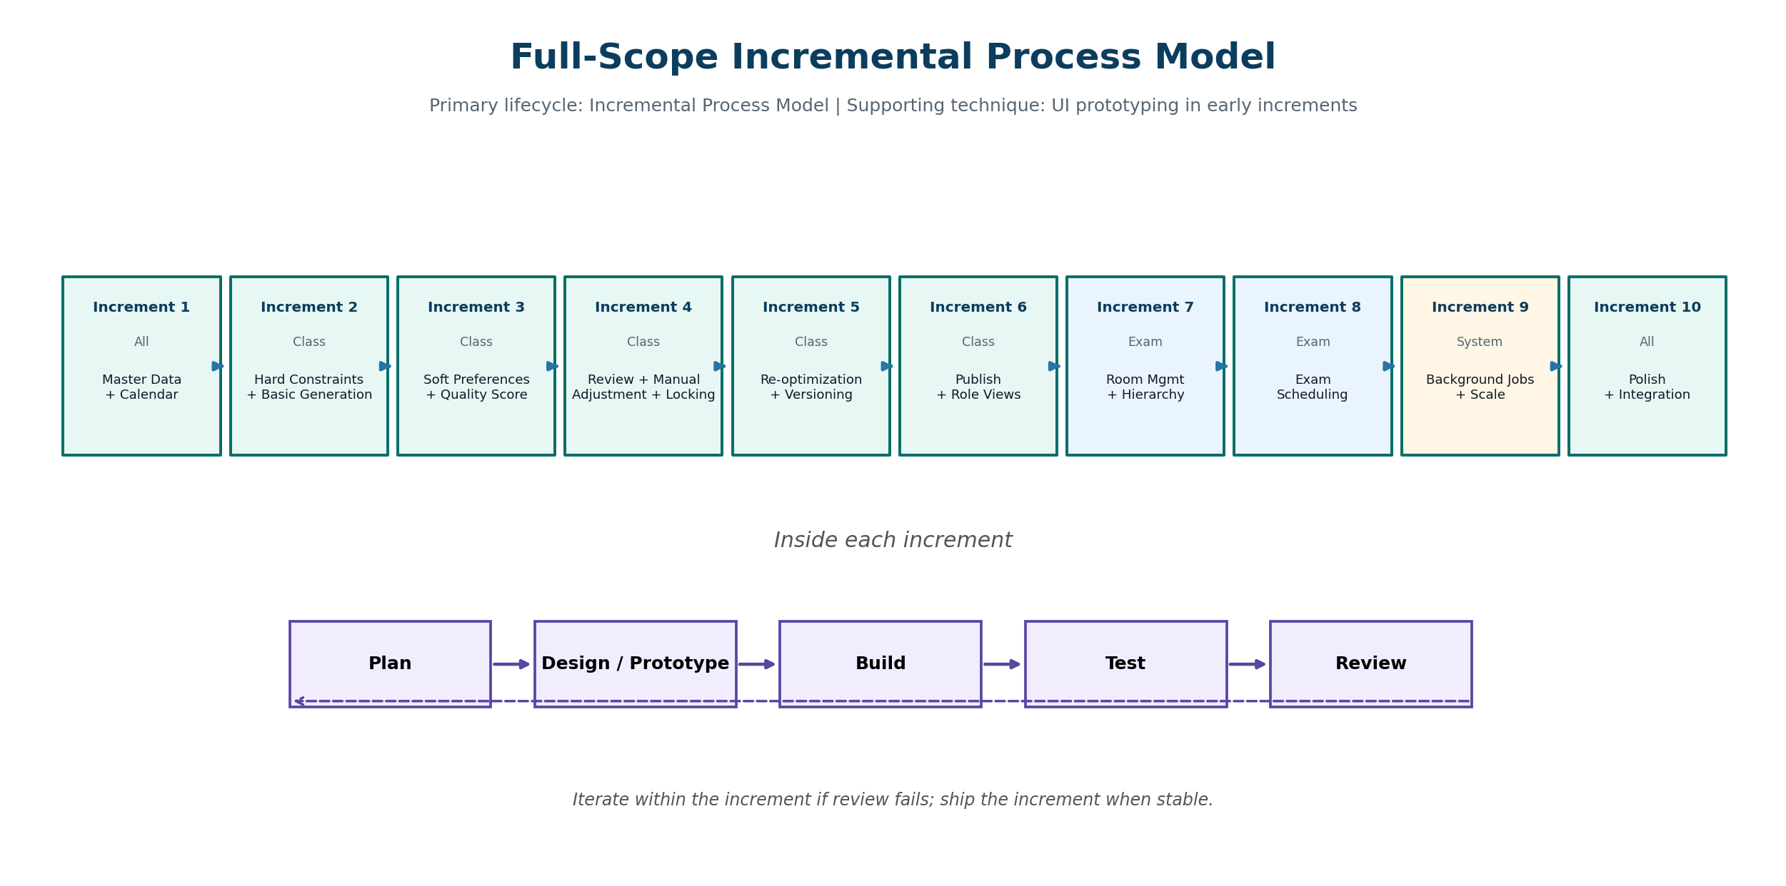
Figure 2.1 - Updated full-scope incremental process model with ten increments.
Increment | Module | Focus | User-Visible Value
1 | All | Master data + academic calendar | Admin can maintain core organization and resource data.
2 | Class | Hard constraints + basic generation | System can enforce no teacher, room, or section clashes.
3 | Class | Soft preferences + quality scoring | Admin can tune preferences and view score breakdown.
4 | Class | Review + manual adjustment + locking | Admin can inspect, fix, and lock timetable entries.
5 | Class | Re-optimization + versioning | Approved changes can be repaired with minimal disruption.
6 | Class | Publish + role views | Teachers and students can view official schedules.
7 | Exam | Room management + student hierarchy | Exam scheduling has room and student enrollment foundations.
8 | Exam | Exam scheduling | System suggests exam placements and avoids double-booking.
9 | System | Background jobs + scale | Long-running generation remains non-blocking.
10 | All | Polish + integration | Final integration, UI consistency, export, notifications, and reports.

3. Requirements Summary from Full-Scope SRS
Requirements are summarized here so the use cases can trace back to the SRS. Detailed requirement numbers are referenced in the expanded use case tables.
Module | Requirement Group | SRS-Aligned Requirement Summary
System-Wide | Authentication and Login | Role selection, admin role login, email/password login for other users, session persistence, logout, password reset, profile view.
System-Wide | Organization Hierarchy | University, Faculty, Department, Batch, Section, academic terms, and versioned timetables.
System-Wide | Export | PDF, Excel, and CSV export for class and exam schedules.
System-Wide | Notifications | Generation complete, publish, request status, approve/reject, lock/unlock, and version-create notifications.
System-Wide | Version Comparison | Side-by-side comparison with added, removed, and changed entries highlighted.
Class Timetabling | Calendar and Master Data | Semester dates, holidays, teachers, rooms, sections, courses, durations, timeslots, and breaks.
Class Timetabling | Constraints and Preferences | Hard rules, teacher availability, lab room rules, room capacity, morning preference, early ending, energy-saving, traffic reduction.
Class Timetabling | Generation and Review | Background generation, conflict detection, unplaced reasons, quality score, room utilization, and teacher load.
Class Timetabling | Adjustment and Publication | Manual adjustment, locked entries, re-optimization, one published timetable per term, and role views.
Exam Timetabling | Exam Scheduling | Exam rooms, student hierarchy, course-exam association, suggestions, admin confirmation, no double-booking, invigilation duties.
Administration | Users, Reports, Audit | User accounts, roles, bulk import, room reports, teacher load reports, conflict summaries, audit logs, and quality reports.

4. Use Case Analysis Approach
- Use cases are defined from actor goals, not from database tables or UI pages.
- High-level use cases are brief and structured so the overall functional scope is easy to understand.
- Expanded use cases are fully dressed: purpose, overview, type, cross-reference, typical course of events, and alternative courses.
- Essential use cases remain abstract and avoid implementation details.
- Real use cases describe the actual UTOS UI behavior using the screenshots supplied with this work.
- Use case diagrams show actor-use case associations only. Business ordering is documented in flows instead of forcing incorrect include or extend relations.
Concept | Meaning in This Document
High-level use case | A brief user-goal description with actors, type, essential goal, and real UI example.
Expanded use case | A detailed narrative of actor actions and system responses for important user goals.
Essential use case | Technology-independent explanation of what the user wants to achieve.
Real use case | Concrete description of the current or planned UTOS screens, controls, buttons, and messages.
Alternative course | A branch or exception such as invalid data, conflict found, access denied, or no feasible schedule.

5. Actors, Goals, and System Boundary
Actor | Type | Goal and Responsibility
Timetable Administrator | Primary | Full access to timetable setup, generation, review, repair, publishing, versioning, and reporting.
Department Coordinator | Primary / Supporting | Validates department data, reviews timetable quality, approves or rejects department change requests, and confirms department-level preferences.
Teacher | Primary | Views personal teaching timetable, submits availability, and requests changes when assigned times or rooms need adjustment.
Student | Primary | Views the published section timetable and exam schedule; receives notifications about published or changed schedules.
Facility Manager | Supporting | Maintains room information, monitors room availability, and reviews room utilization and capacity reports.
System Administrator | Primary | Manages user accounts, role permissions, backups, security settings, audit log visibility, and system configuration.

5.1 System Boundary
The System under Discussion (SuD) is the UTOS web application, including frontend, backend API, database, scheduling solver orchestration, notifications, versioning, and reporting. Human actors remain outside the boundary. The solver engine is treated as an internal technical component in architecture diagrams rather than as a primary actor in use case diagrams.
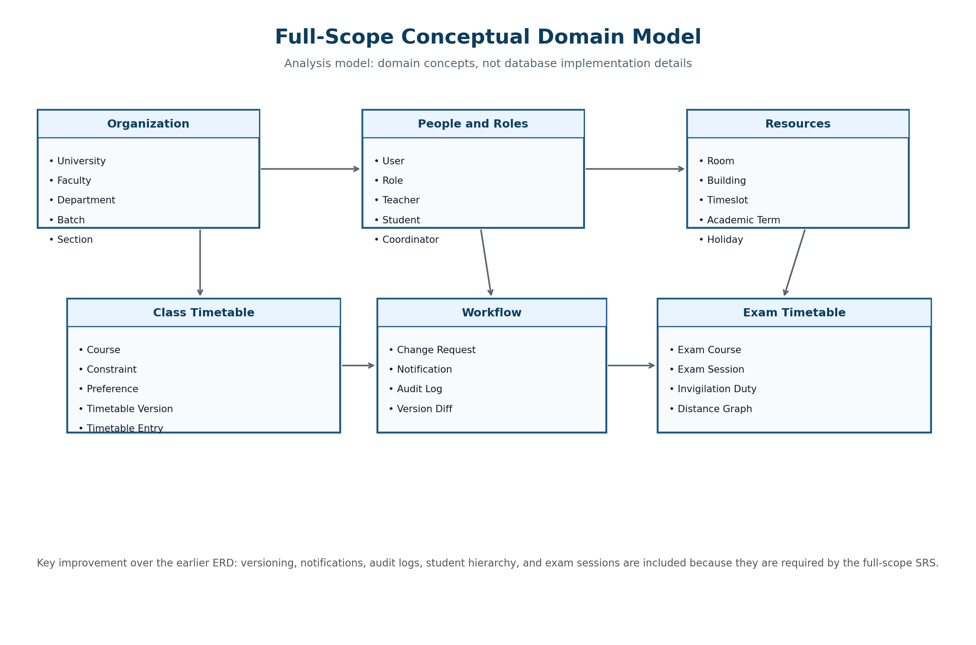
Figure 5.1 - Full-scope conceptual domain model aligned with SRS v1.0.

6. High-Level Use Case Summary
ID | Use Case | Module | Primary Actor | Essential Goal | Real UI / System Behavior
UC00 | Authenticate and Login | System-wide | All users | Select role, enter credentials, and establish a session. | Login screen supports role selection, admin role login, user email/password login, refresh persistence, and logout.
UC01 | Maintain Organization Hierarchy | System-wide | Timetable Administrator | Define university, faculty, department, batch, section, and academic term structure. | Admin configures hierarchy so each course, teacher, student, and timetable version belongs to the correct unit.
UC02 | Maintain Academic Calendar | Class Timetabling | Timetable Administrator | Define semester dates, holidays, blackout dates, working days, and makeup-class windows. | Calendar settings prevent scheduling on blocked days and allow future makeup class planning.
UC03 | Manage Master Data | Class Timetabling | Timetable Administrator | Maintain teachers, rooms, courses, sections, timeslots, room types, capacity, and facilities. | Admin uses Teachers and Rooms Management screens to add, update, delete, search, filter, and validate data.
UC04 | Define Constraints and Preferences | Class Timetabling | Timetable Administrator | Configure hard constraints and weighted soft preferences. | Admin enables hard rules and sets preference weights for morning, early finish, energy saving, room proximity, and traffic reduction.
UC05 | Generate Class Timetable | Class Timetabling | Timetable Administrator | Create a draft weekly timetable satisfying hard rules and optimizing soft goals. | Admin clicks Generate Draft; the backend validates data, runs the solver, saves a draft version, and displays results.
UC06 | Review Timetable Quality | Class Timetabling | Timetable Administrator | Inspect conflicts, warnings, unplaced classes, quality score, room utilization, and teacher load. | Schedule Control Center displays draft timetable, conflict cards, locked entries, and quality feedback.
UC07 | Manually Adjust and Lock Timetable | Class Timetabling | Timetable Administrator | Move timetable entries manually and protect selected entries from later solver changes. | Admin drags or edits entries, uses lock icons, and the system validates each change before saving.
UC08 | Submit Change Request | Class Timetabling | Teacher / Coordinator | Request a teacher, room, or time change without directly editing the official timetable. | Teacher or coordinator opens the Change Request Form, enters summary/reason, and optionally attaches evidence.
UC09 | Approve or Reject Change Request | Class Timetabling | Department Coordinator / Timetable Administrator | Review request details, check conflicts, and decide whether the requested change is accepted. | Reviewer opens the request modal, sees current/proposed schedule, conflict check, and clicks Approve or Reject.
UC10 | Re-optimize Timetable | Class Timetabling | Timetable Administrator | Repair the timetable after approved changes while minimizing disturbance. | Admin triggers repair mode; locked entries stay fixed and the solver changes only the affected portion when possible.
UC11 | Publish Timetable | Class Timetabling | Timetable Administrator | Release the approved timetable as the official version for the term. | Final confirmation screen shows timetable name, effective date, total entries, clear conflicts, and publish warning.
UC12 | View Personal or Section Timetable | Class Timetabling | Teacher / Student | View the published timetable filtered to the role and identity of the user. | Teachers see personal teaching load; students see section schedule with day, time, course, room, and teacher.
UC13 | Export Class Timetable | System-wide | Timetable Administrator | Export timetable to PDF, Excel, or CSV in a usable format. | Export buttons produce printable A4/PDF and structured files with day, time, course, teacher, room, and section.
UC14 | Manage Notifications | System-wide | System / Users | Notify users when generation completes, timetable is published, entries lock/unlock, requests change status, or new versions are created. | Users see notification history and unread count; events create in-app notifications.
UC15 | Compare Timetable Versions | System-wide | Timetable Administrator | Compare two timetable versions and summarize added, removed, and changed entries. | Admin opens version comparison; the system highlights changes and shows totals.
UC16 | Manage Exam Rooms | Exam Timetabling | Timetable Administrator / Facility Manager | Maintain exam room capacity, room type, and room availability. | Class room data is reused; exam-specific room suitability can be reviewed before exam scheduling.
UC17 | Manage Student Hierarchy | Exam Timetabling | Timetable Administrator | Maintain University -> Faculty -> Department -> Batch -> Section -> Student hierarchy. | Admin views nested student tree and imports/updates section membership and course enrollment.
UC18 | Manage Exam Courses | Exam Timetabling | Timetable Administrator | Associate courses with exams, exam durations, and taking sections. | Admin configures exam course list, durations, and affected student sections.
UC19 | Schedule Exams | Exam Timetabling | Timetable Administrator | Generate or suggest exam room/time placements while preventing student and room conflicts. | System suggests exam slots; admin confirms or modifies; no student is double-booked.
UC20 | View Exam Schedule and Invigilation Duties | Exam Timetabling | Student / Teacher / Facility Manager | View exam schedule, invigilation duties, and room usage. | Students view own exams; teachers view invigilation duties; facility manager checks exam room utilization.
UC21 | Manage Users and Roles | Administration | System Administrator | Create accounts, assign roles, bulk import students, and enforce access permissions. | System administrator manages accounts; role-specific sidebars and permissions limit available actions.
UC22 | View System Reports and Audit Logs | Administration | Admin / Facility Manager / System Administrator | Review room utilization, teacher load, conflict summaries, energy usage, quality score, and action history. | Reports screens show stats, charts, detailed tables, action history, timestamps, and old/new values.

7. Expanded Use Cases: Essential and Real

UC00 - Authenticate and Login
Field | Detail
Scope | System-wide
Level | User goal
Primary Actor | All users
Supporting Actors | System Administrator
Type | Primary, Essential and Real
Purpose | Allow authorized users to enter UTOS with role-appropriate access.
Overview | A user selects a role and signs in. The system validates credentials, stores a session, opens the correct dashboard, and enforces role-based navigation.
Cross Reference | FR-00.1 to FR-00.6c; NFR-05 security; role-based access requirements.

Essential Use Case - Typical Course of Events
Actor Action | System Response
1. This use case begins when a user requests access to UTOS. | 2. The system asks for identity and role information.
3. The user provides valid login information. | 4. The system verifies the user and determines the assigned role.
5. The user confirms the login action. | 6. The system starts a session and grants access to permitted functions.
7. The user may later request logout. | 8. The system ends the session.

Real Use Case - Current/Planned UTOS Interface Behavior
Actor Action | System Response
1. The user opens the single UTOS login screen. | 2. The system displays role cards such as Admin, Coordinator, Teacher, Student, and Facility Manager.
3. The user selects a role and signs in. | 4. The system stores the session in the browser and opens the role-specific dashboard.
5. The user navigates by using the sidebar. | 6. The sidebar shows only allowed options such as Timetable, Requests, Master Data, or Reports.
7. The user clicks Logout. | 8. The system clears the session and returns to the login screen.

Alternative Courses
Line | Alternative / Exception
3a | If credentials are invalid, the system rejects the login and shows a plain-language error.
4a | If the user has no assigned role, the system denies access and asks the user to contact the system administrator.
6a | If a non-admin user remains inactive, the system may auto-logout according to security settings.

UC03 - Manage Master Data
Field | Detail
Scope | Class Timetabling
Level | User goal
Primary Actor | Timetable Administrator
Supporting Actors | Department Coordinator; Facility Manager
Type | Primary, Essential and Real
Purpose | Maintain the validated data the solver requires before timetable generation.
Overview | The administrator manages teachers, rooms, courses, sections, timeslots, room capacities, room types, and facilities. This use case also prepares shared room data for the exam module.
Cross Reference | FR-02.1 to FR-02.6b; FR-15.1 to FR-15.4 for reusable room data.

Essential Use Case - Typical Course of Events
Actor Action | System Response
1. This use case begins when the Timetable Administrator chooses to maintain scheduling data. | 2. The system presents the available master-data categories.
3. The administrator creates or edits a record. | 4. The system validates required fields, duplicates, capacity, and relationship rules.
5. The administrator saves the record. | 6. The system stores the record and makes it available to generation and reporting.
7. A coordinator or facility manager reviews relevant data. | 8. The system shows filtered views according to role.

Real Use Case - Current/Planned UTOS Interface Behavior
Actor Action | System Response
1. The administrator opens Master Data from the sidebar. | 2. The system displays screens such as Teachers Management and Rooms Management.
3. The administrator searches, filters, adds, edits, deletes, or selects records. | 4. The system validates teacher IDs, email, department, room capacity, room type, building, and maintenance status.
5. The administrator clicks Apply Data Changes or Save. | 6. The system persists the changes and refreshes dashboard counts.
7. The facility manager opens room records or reports. | 8. The system shows total rooms, lecture halls, labs, seminar rooms, and under-maintenance rooms.

Alternative Courses
Line | Alternative / Exception
4a | If a required field is missing, the system blocks saving and highlights the field.
4b | If a room capacity is smaller than linked section size, the system warns the user.
5a | If the record is used by an existing timetable entry, deletion is blocked or requires replacement.

UC04 - Define Constraints and Preferences
Field | Detail
Scope | Class Timetabling
Level | User goal
Primary Actor | Timetable Administrator
Supporting Actors | Department Coordinator; Teacher
Type | Primary, Essential and Real
Purpose | Configure the rulebook that determines timetable feasibility and quality.
Overview | Hard constraints must be enforced, while soft preferences are enabled, disabled, or weighted according to institutional policy.
Cross Reference | FR-03.1 to FR-03.15.

Essential Use Case - Typical Course of Events
Actor Action | System Response
1. This use case begins when the administrator decides to configure scheduling rules. | 2. The system shows hard constraints and soft preference options.
3. The administrator chooses active rules and priority weights. | 4. The system checks whether the configuration is complete and consistent.
5. The administrator confirms the configuration. | 6. The system saves it as the active rule configuration for future generation.
7. Teachers may provide availability restrictions. | 8. The system stores unavailable slots as constraint data.

Real Use Case - Current/Planned UTOS Interface Behavior
Actor Action | System Response
1. The administrator opens the constraints/preferences screen. | 2. The system lists rules such as no teacher clash, no room clash, room capacity, lab-only rooms, holiday exclusion, and teacher availability.
3. The administrator toggles soft options such as morning preference, early ending, energy-saving compaction, room proximity, and traffic reduction. | 4. The system records priority weights and displays which preferences are active.
5. The administrator saves the active profile. | 6. The next Generate Draft run uses this profile.

Alternative Courses
Line | Alternative / Exception
4a | If a soft-preference weight is outside the allowed range, the system requests correction.
4b | If a hard rule is disabled in a way that could make results unsafe, the system requires confirmation or prevents disabling.

UC05 - Generate Class Timetable
Field | Detail
Scope | Class Timetabling
Level | User goal
Primary Actor | Timetable Administrator
Supporting Actors | Solver Engine
Type | Primary, Essential and Real
Purpose | Produce a draft class timetable for an academic term.
Overview | The administrator starts generation. The system validates data, builds a problem model, runs the solver, saves the result as a draft version, and displays status, score, conflicts, and unplaced sessions.
Cross Reference | FR-04.1 to FR-04.7c; FR-05.1 to FR-05.5; versioning requirements.

Essential Use Case - Typical Course of Events
Actor Action | System Response
1. This use case begins when the Timetable Administrator requests generation for an academic term. | 2. The system identifies the selected term, departments, sections, courses, teachers, rooms, timeslots, calendar, and constraints.
3. The administrator confirms that generation should begin. | 4. The system validates that required data exists and that constraints are usable.
5. The administrator waits for the result. | 6. The system attempts to assign every class session to a valid room and timeslot.
7. The administrator reviews the generated result. | 8. The system stores the result as a draft version and shows feasibility status, conflicts, unplaced sessions, and quality score.

Real Use Case - Current/Planned UTOS Interface Behavior
Actor Action | System Response
1. The administrator opens Schedule Control Center. | 2. The dashboard shows current counts for teachers, rooms, sections, courses, and generation status.
3. The administrator clicks Generate Draft. | 4. The frontend calls the backend API and shows a progress indicator.
5. The backend validates data, sends a problem model to the solver, receives assignments, and writes a draft version. | 6. The UI redirects to the draft review timetable grid.
7. The administrator views draft entries, lock icons, conflicts, and warnings. | 8. The system keeps the draft available for review, locking, comparison, or publishing.

Alternative Courses
Line | Alternative / Exception
4a | If master data is missing, the system lists missing teachers, rooms, timeslots, courses, or sections and stops generation.
6a | If no complete timetable is feasible, the system saves the partial result and lists unplaced sessions with reasons.
6b | If a conflict is detected, the system tries alternate room/time assignments before reporting failure.

UC06 - Review Timetable Quality
Field | Detail
Scope | Class Timetabling
Level | User goal
Primary Actor | Timetable Administrator
Supporting Actors | Department Coordinator; Facility Manager
Type | Primary, Essential and Real
Purpose | Evaluate whether the generated draft is feasible, acceptable, and efficient before publication.
Overview | The system shows timetable grid, conflicts, quality score, room usage, teacher load, and soft-constraint penalties. Reviewers decide whether to accept, adjust, or regenerate.
Cross Reference | FR-05.1 to FR-05.5; FR-21.1 to FR-21.8.

Essential Use Case - Typical Course of Events
Actor Action | System Response
1. This use case begins when the administrator opens a generated timetable draft. | 2. The system displays the weekly timetable and summary status.
3. The administrator examines conflicts and warnings. | 4. The system shows affected entries and explains each issue.
5. The administrator checks quality information. | 6. The system shows score, room utilization, teacher load, and penalty breakdown.
7. The administrator decides whether the result is acceptable. | 8. The system allows moving forward to locking, re-optimization, or publishing.

Real Use Case - Current/Planned UTOS Interface Behavior
Actor Action | System Response
1. The administrator opens draft review mode. | 2. The UI shows a green review banner, timetable grid, locked/mutable legend, and red conflict cards.
3. The administrator clicks a conflict or highlighted entry. | 4. The system reveals which courses, rooms, teachers, or sections collide.
5. The coordinator reviews department assignments. | 6. The system shows filtered department data and report panels.
7. The facility manager opens room reports. | 8. The system shows room occupancy, peak hours, and underused rooms.

Alternative Courses
Line | Alternative / Exception
3a | If a conflict is unacceptable, the administrator sends the draft to manual adjustment or re-optimization.
7a | If the draft has zero hard conflicts but poor soft score, the administrator may tune preferences and regenerate.

UC07 - Manually Adjust and Lock Timetable
Field | Detail
Scope | Class Timetabling
Level | User goal
Primary Actor | Timetable Administrator
Supporting Actors | Department Coordinator
Type | Primary, Essential and Real
Purpose | Allow controlled manual editing and preserve important assignments from future solver changes.
Overview | The administrator adjusts entries and locks selected timetable assignments. Locked entries become fixed constraints during re-optimization.
Cross Reference | FR-06.1 to FR-06.4; FR-07.1 to FR-07.3.

Essential Use Case - Typical Course of Events
Actor Action | System Response
1. This use case begins when the administrator chooses an entry that needs adjustment or preservation. | 2. The system shows the selected entry and editable assignment choices.
3. The administrator moves an entry or marks it locked. | 4. The system validates the change against teacher, room, section, and timeslot constraints.
5. The administrator confirms the change. | 6. The system saves the change, records audit history, and updates the draft.
7. The administrator runs future repair if needed. | 8. The system keeps locked entries unchanged.

Real Use Case - Current/Planned UTOS Interface Behavior
Actor Action | System Response
1. The administrator opens the draft timetable grid. | 2. The UI shows entries with padlock icons and dashed outlines for mutable draft entries.
3. The administrator locks a preserved class or edits a room/time. | 4. The system checks conflicts and highlights any invalid target slot.
5. The administrator saves. | 6. The system updates the visual grid and logs who changed the entry.

Alternative Courses
Line | Alternative / Exception
4a | If the chosen room is already occupied, the system rejects the move and displays the colliding entry.
4b | If the entry is already published, the system requires a new draft or authorized revision workflow.

UC08 - Submit Change Request
Field | Detail
Scope | Class Timetabling
Level | User goal
Primary Actor | Teacher or Department Coordinator
Supporting Actors | Timetable Administrator
Type | Primary, Essential and Real
Purpose | Provide a structured way to request schedule changes without direct timetable editing.
Overview | A teacher or coordinator submits a request with subject, summary, reason, and optional document. The system records it as pending and notifies reviewers.
Cross Reference | FR-10.1 to FR-10.3; notification requirements.

Essential Use Case - Typical Course of Events
Actor Action | System Response
1. This use case begins when a teacher or coordinator needs a timetable change. | 2. The system offers a request submission function.
3. The requester describes the change and reason. | 4. The system validates that the request is connected to a timetable item or valid context.
5. The requester submits the request. | 6. The system records the request with status Pending and notifies reviewers.

Real Use Case - Current/Planned UTOS Interface Behavior
Actor Action | System Response
1. The teacher opens the Change Request Form. | 2. The UI displays subject, request summary, reason, and attach document controls.
3. The teacher enters the requested change and optional reason. | 4. The system accepts the attachment if it meets size/type limits.
5. The teacher clicks Submit Request. | 6. The system stores the request and returns a confirmation/status view.

Alternative Courses
Line | Alternative / Exception
4a | If an attachment is larger than the allowed limit, the system asks the user to remove or replace it.
5a | If the request summary is empty, the system asks for enough details before submission.

UC09 - Approve or Reject Change Request
Field | Detail
Scope | Class Timetabling
Level | User goal
Primary Actor | Department Coordinator or Timetable Administrator
Supporting Actors | Teacher
Type | Primary, Essential and Real
Purpose | Review a submitted request and decide whether it should affect the timetable.
Overview | A reviewer examines details, checks conflicts, approves or rejects the request, optionally comments, and triggers status notification.
Cross Reference | FR-10.2; FR-10.3; FR-07.1; notification requirements.

Essential Use Case - Typical Course of Events
Actor Action | System Response
1. This use case begins when a reviewer opens a pending change request. | 2. The system displays request details, requester, affected course, current schedule, and proposed change.
3. The reviewer evaluates the request. | 4. The system provides conflict check and supporting data.
5. The reviewer approves or rejects the request. | 6. The system records the decision, updates request status, and notifies the requester.
7. If approved, the reviewer may trigger timetable repair. | 8. The system sends the approved change to re-optimization or manual adjustment workflow.

Real Use Case - Current/Planned UTOS Interface Behavior
Actor Action | System Response
1. The coordinator opens Change Requests Management. | 2. The UI displays pending, approved, and rejected counts plus a request list.
3. The reviewer opens a modal for request #101. | 4. The system shows course, current time, proposed time, reason, and conflict check.
5. The reviewer clicks Approve or Reject and may add a comment. | 6. The system changes request status and creates a notification.

Alternative Courses
Line | Alternative / Exception
4a | If the conflict check fails, the reviewer may reject the request or route it to re-optimization.
5a | If the reviewer lacks authority, the system disables decision buttons.

UC10 - Re-optimize Timetable
Field | Detail
Scope | Class Timetabling
Level | User goal
Primary Actor | Timetable Administrator
Supporting Actors | Solver Engine
Type | Primary, Essential and Real
Purpose | Repair the timetable after approved changes while minimizing disturbance.
Overview | The administrator triggers repair mode. The solver respects locked entries and attempts to change the smallest possible set of timetable entries.
Cross Reference | FR-07.1 to FR-07.3; version comparison requirements.

Essential Use Case - Typical Course of Events
Actor Action | System Response
1. This use case begins when an approved change requires timetable repair. | 2. The system identifies affected courses, teachers, rooms, sections, and locked entries.
3. The administrator starts re-optimization. | 4. The system builds a repair problem preserving accepted and locked entries.
5. The administrator waits for the repair result. | 6. The system produces an updated draft and disruption summary.
7. The administrator compares old and new drafts. | 8. The system highlights moved, added, and unchanged entries.

Real Use Case - Current/Planned UTOS Interface Behavior
Actor Action | System Response
1. The administrator selects an approved request or draft conflict. | 2. The UI shows a Re-optimize action.
3. The administrator clicks Re-optimize. | 4. The backend runs solver repair mode with locked entries as fixed assignments.
5. The system saves a new version. | 6. The UI shows which entries changed and how many conflicts remain.

Alternative Courses
Line | Alternative / Exception
4a | If no valid repair exists, the system reports unplaced sessions and explains blocking constraints.
7a | If disruption is too high, the administrator may reject the repair and keep the previous version.

UC11 - Publish Timetable
Field | Detail
Scope | Class Timetabling
Level | User goal
Primary Actor | Timetable Administrator
Supporting Actors | Department Coordinator; Teacher; Student
Type | Primary, Essential and Real
Purpose | Release the approved timetable as the official live schedule for users.
Overview | The administrator confirms publication after review. The system marks the final version as published, makes it visible to teachers and students, and warns about overwriting previous public schedules.
Cross Reference | FR-08.1 to FR-08.4b; export and notification requirements.

Essential Use Case - Typical Course of Events
Actor Action | System Response
1. This use case begins when the administrator decides the timetable is ready for release. | 2. The system checks whether required approvals and conflict status allow publication.
3. The administrator reviews final publication details. | 4. The system shows effective date, timetable name, total entries, visibility, and warning.
5. The administrator confirms publication. | 6. The system marks the version published, hides older public versions, and notifies users.
7. Teachers and students open the system. | 8. The system shows the published timetable filtered to their role.

Real Use Case - Current/Planned UTOS Interface Behavior
Actor Action | System Response
1. The administrator opens Publish Final Confirmation. | 2. The UI shows workflow steps: Draft Generated, Conflict Review, Locks Applied, Confirm Publish, Published.
3. The administrator reviews Fall 2026 Final, effective date, total entries, and conflict status. | 4. The system shows 100% clear status and public visibility text.
5. The administrator clicks Confirm and Publish Now. | 6. The system records publication timestamp and updates teacher/student dashboards.

Alternative Courses
Line | Alternative / Exception
2a | If conflicts remain, the system blocks publication or requires override authority.
5a | If the administrator cancels, the timetable remains a draft.

UC19 - Schedule Exams
Field | Detail
Scope | Exam Timetabling
Level | User goal
Primary Actor | Timetable Administrator
Supporting Actors | Student; Teacher; Facility Manager
Type | Primary, Essential and Real
Purpose | Place exam sessions into rooms and time slots while avoiding student and room clashes.
Overview | The administrator configures exam courses, durations, rooms, and student sections. The system suggests room/time placements and invigilation assignments for confirmation.
Cross Reference | FR-18.1 to FR-18.8; FR-19.1 to FR-19.5.

Essential Use Case - Typical Course of Events
Actor Action | System Response
1. This use case begins when the administrator starts exam scheduling for a term. | 2. The system loads exam courses, enrolled sections, students, available rooms, and exam rules.
3. The administrator requests scheduling suggestions. | 4. The system finds room/time candidates that avoid room double-booking and student exam overlap.
5. The administrator confirms or modifies suggestions. | 6. The system saves exam sessions and updates exam schedule views.
7. Students, teachers, and facility managers request exam views. | 8. The system shows schedules relevant to each role.

Real Use Case - Current/Planned UTOS Interface Behavior
Actor Action | System Response
1. The administrator opens the exam timetable module. | 2. The UI lists exam courses, duration, taking sections, and room capacity data.
3. The administrator clicks Suggest Schedule. | 4. The system proposes exam sessions starting at allowed times and checks 15-minute check-in time.
5. The administrator confirms or edits room/time. | 6. The system stores exam sessions, invigilation duties, and exportable schedules.

Alternative Courses
Line | Alternative / Exception
4a | If exam days are running out, the system may allow a maximum of two exams per day per student as specified by rules.
4b | If no room has enough capacity, the system reports the capacity gap and suggests splitting or larger room assignment.

UC22 - View System Reports and Audit Logs
Field | Detail
Scope | Administration
Level | User goal
Primary Actor | Timetable Administrator; Facility Manager; System Administrator
Supporting Actors | Department Coordinator
Type | Primary, Essential and Real
Purpose | Support operational review, accountability, and future timetable improvement.
Overview | Users with permission view room utilization, teacher load, conflict summaries, section load, quality score, energy usage, and audit logs.
Cross Reference | FR-21.1 to FR-21.8; NFR-07 audit logging.

Essential Use Case - Typical Course of Events
Actor Action | System Response
1. This use case begins when an authorized user requests a report. | 2. The system displays report types and filters.
3. The user chooses report type, period, building, department, or term. | 4. The system collects relevant timetable, room, teacher, and audit data.
5. The user reviews the result. | 6. The system shows charts, tables, warnings, and export/print options.
7. The user opens audit history. | 8. The system shows action, timestamp, user, and old/new values.

Real Use Case - Current/Planned UTOS Interface Behavior
Actor Action | System Response
1. The facility manager opens Reports: Room Utilization. | 2. The UI shows average occupancy, peak usage, monitored rooms, low-utilization rooms, charts, heatmap, and detailed table.
3. The coordinator opens Reports: Teacher Load. | 4. The UI shows teachers monitored, average load, overloaded and underloaded counts, visual load bars, and action buttons.
5. The system administrator opens audit logs. | 6. The system shows who changed each record and when.

Alternative Courses
Line | Alternative / Exception
2a | If the user lacks permission, the report is hidden or access is denied.
4a | If there is no data for the selected period, the system shows an empty-state message rather than failing.

8. Updated Use Case Diagrams
The earlier single diagram is useful as a starting point, but the full SRS contains too many goals for one clean diagram. The improved model splits use cases into a class-timetabling diagram and an exam/system-wide diagram.
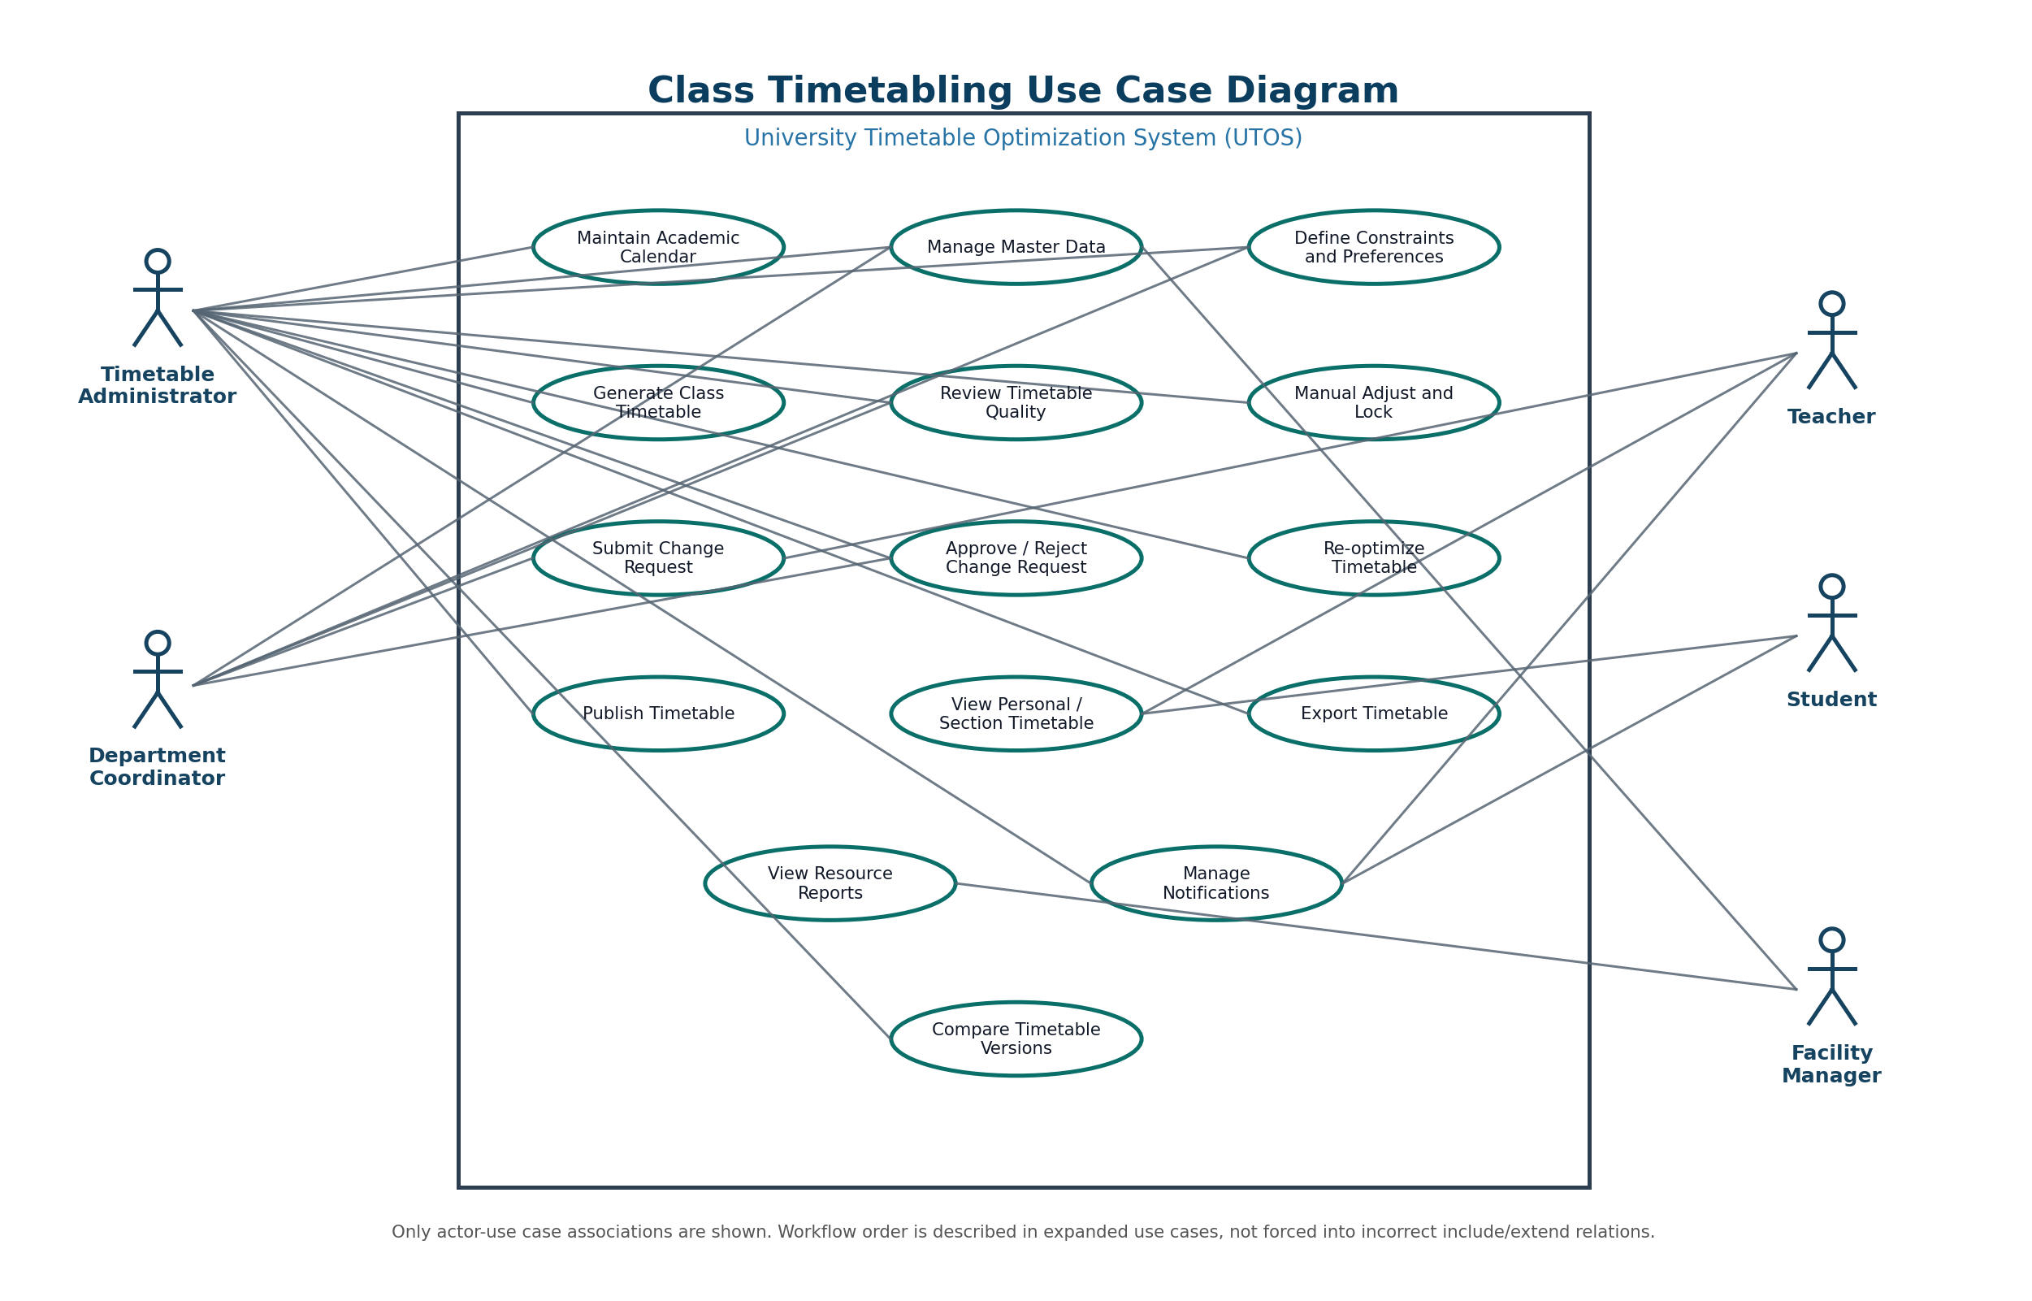
Figure 8.1 - Updated class timetabling use case diagram.
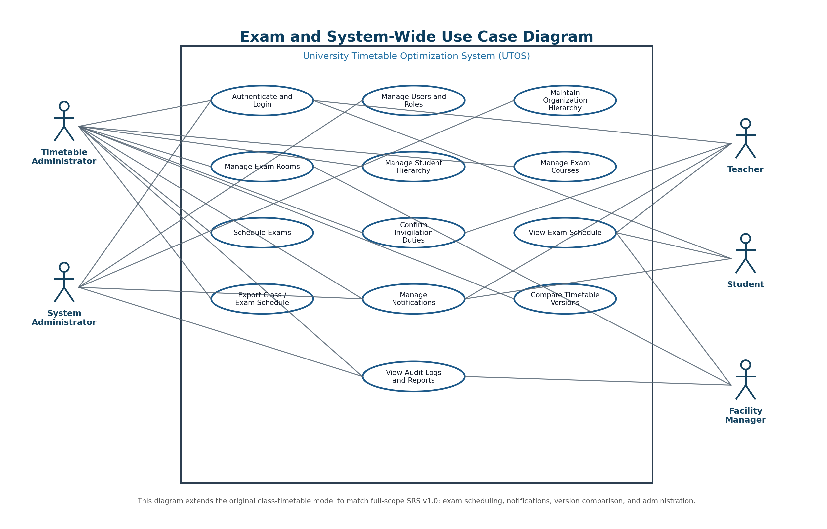
Figure 8.2 - Updated exam and system-wide use case diagram.
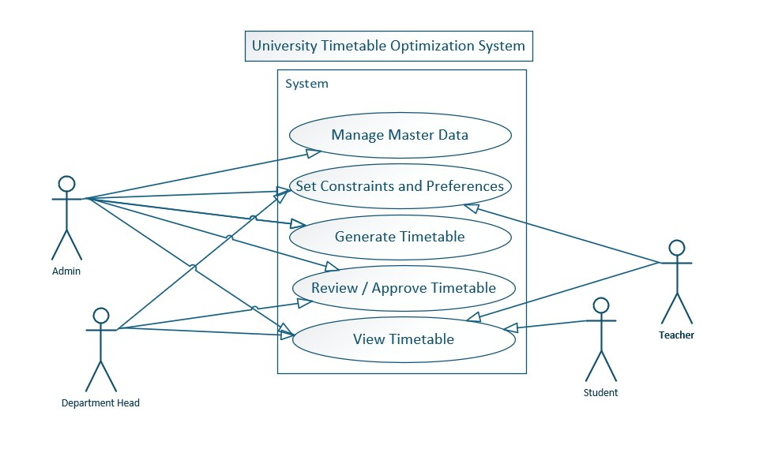
Figure 8.3 - Original/simple use case diagram retained as a baseline reference.
.

9.4 Architecture Diagram
The architecture is best presented as four separable components: Web Frontend, Backend API, Database, and Solver Engine. The solver boundary is important because the SRS expects future replacement by stronger optimization technology without rewriting the UI.
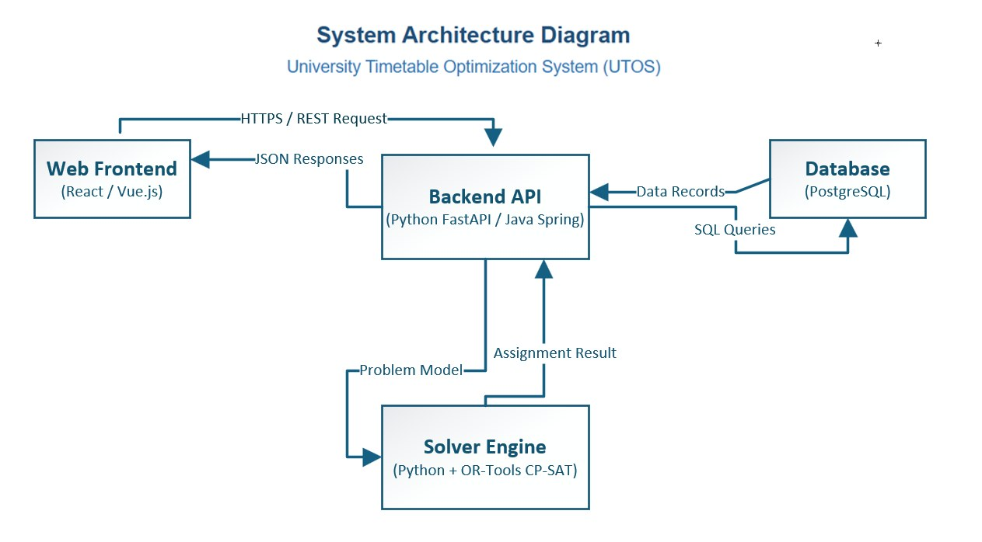
Figure 9.7 - Final architecture diagram with frontend, backend API, database, and solver engine.

10. UI Screenshots and Real Use Case Evidence
The following screenshots are included as real-use-case evidence. They show how the SRS and use cases appear in the current/prototype interface.
Screenshot Area | Related Use Cases | What It Demonstrates
Role login and role-specific sidebars | UC00, UC21 | Role selection, session behavior, and role-based navigation.
Schedule Control Center dashboard | UC05, UC06 | Dashboard counts, draft status, generation entry point, and timetable grid.
Draft review with conflicts and locks | UC06, UC07 | Conflict visualization, locked entries, mutable draft entries, and review mode.
Master Data - Teachers and Rooms | UC03, UC16 | Teacher and room record management, filters, search, actions, and room capacity/status data.
Change Request Form and Review Modal | UC08, UC09 | Request submission, optional documents, review workflow, conflict check, approve/reject decision.
Reports - Room Utilization and Teacher Load | UC22 | Operational reports, statistics, charts, load status, utilization table, and export/print actions.
Publish Final Confirmation | UC11 | Final publish workflow, conflict status, effective date, public visibility, and irreversible publish warning.
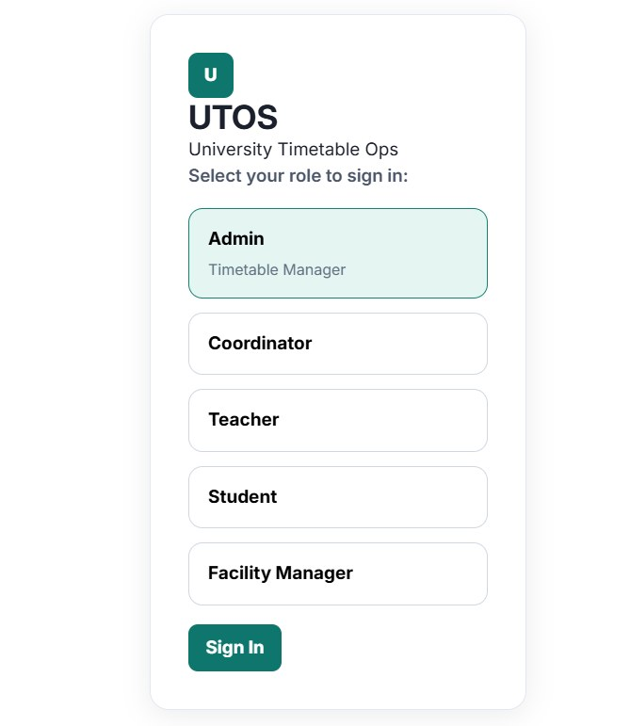
Figure 10.1 - Role-selection login screen for UTOS.
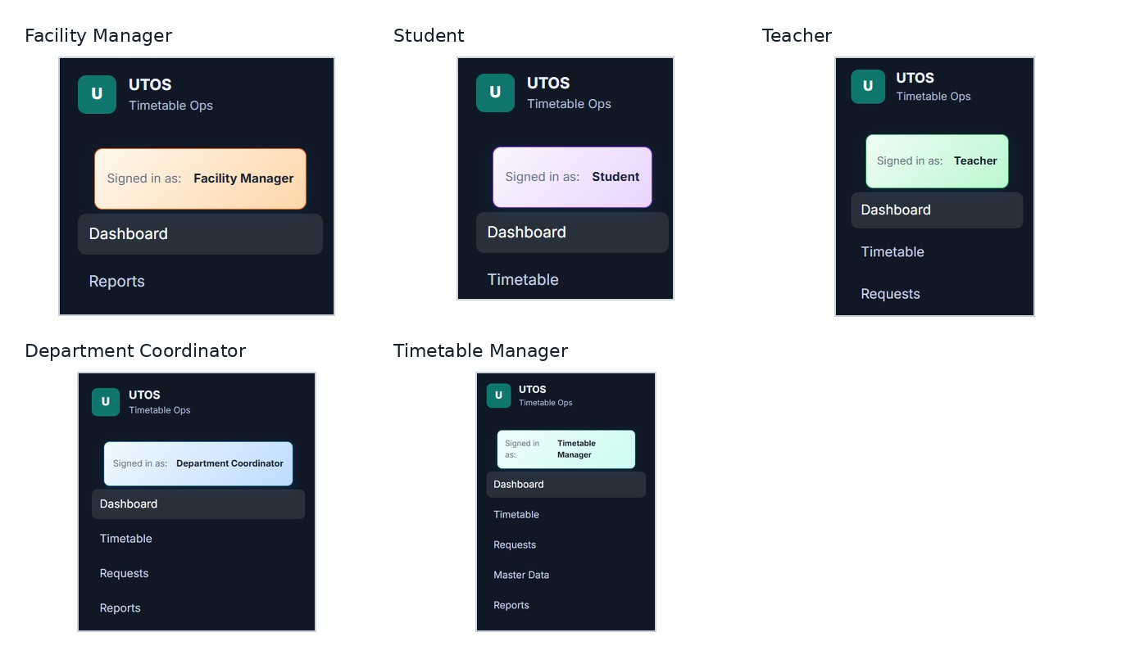
Figure 10.2 - Role-specific sidebar examples for Facility Manager, Student, Teacher, Department Coordinator, and Timetable Manager.
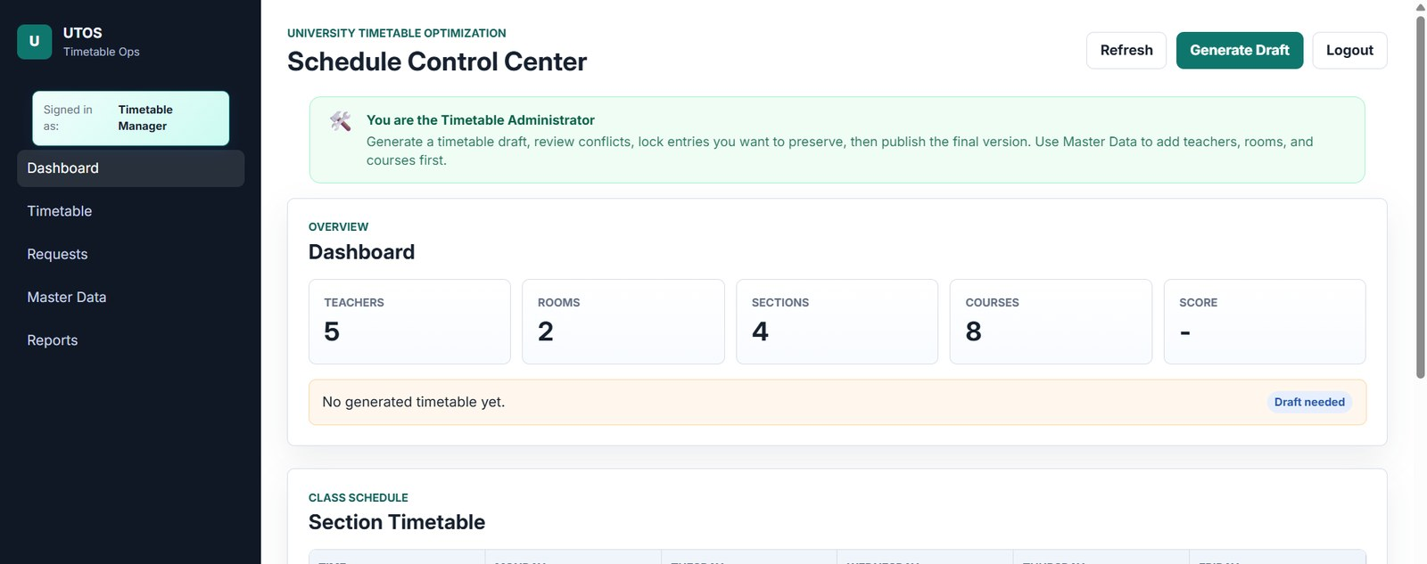
Figure 10.3 - Schedule Control Center dashboard before generation.
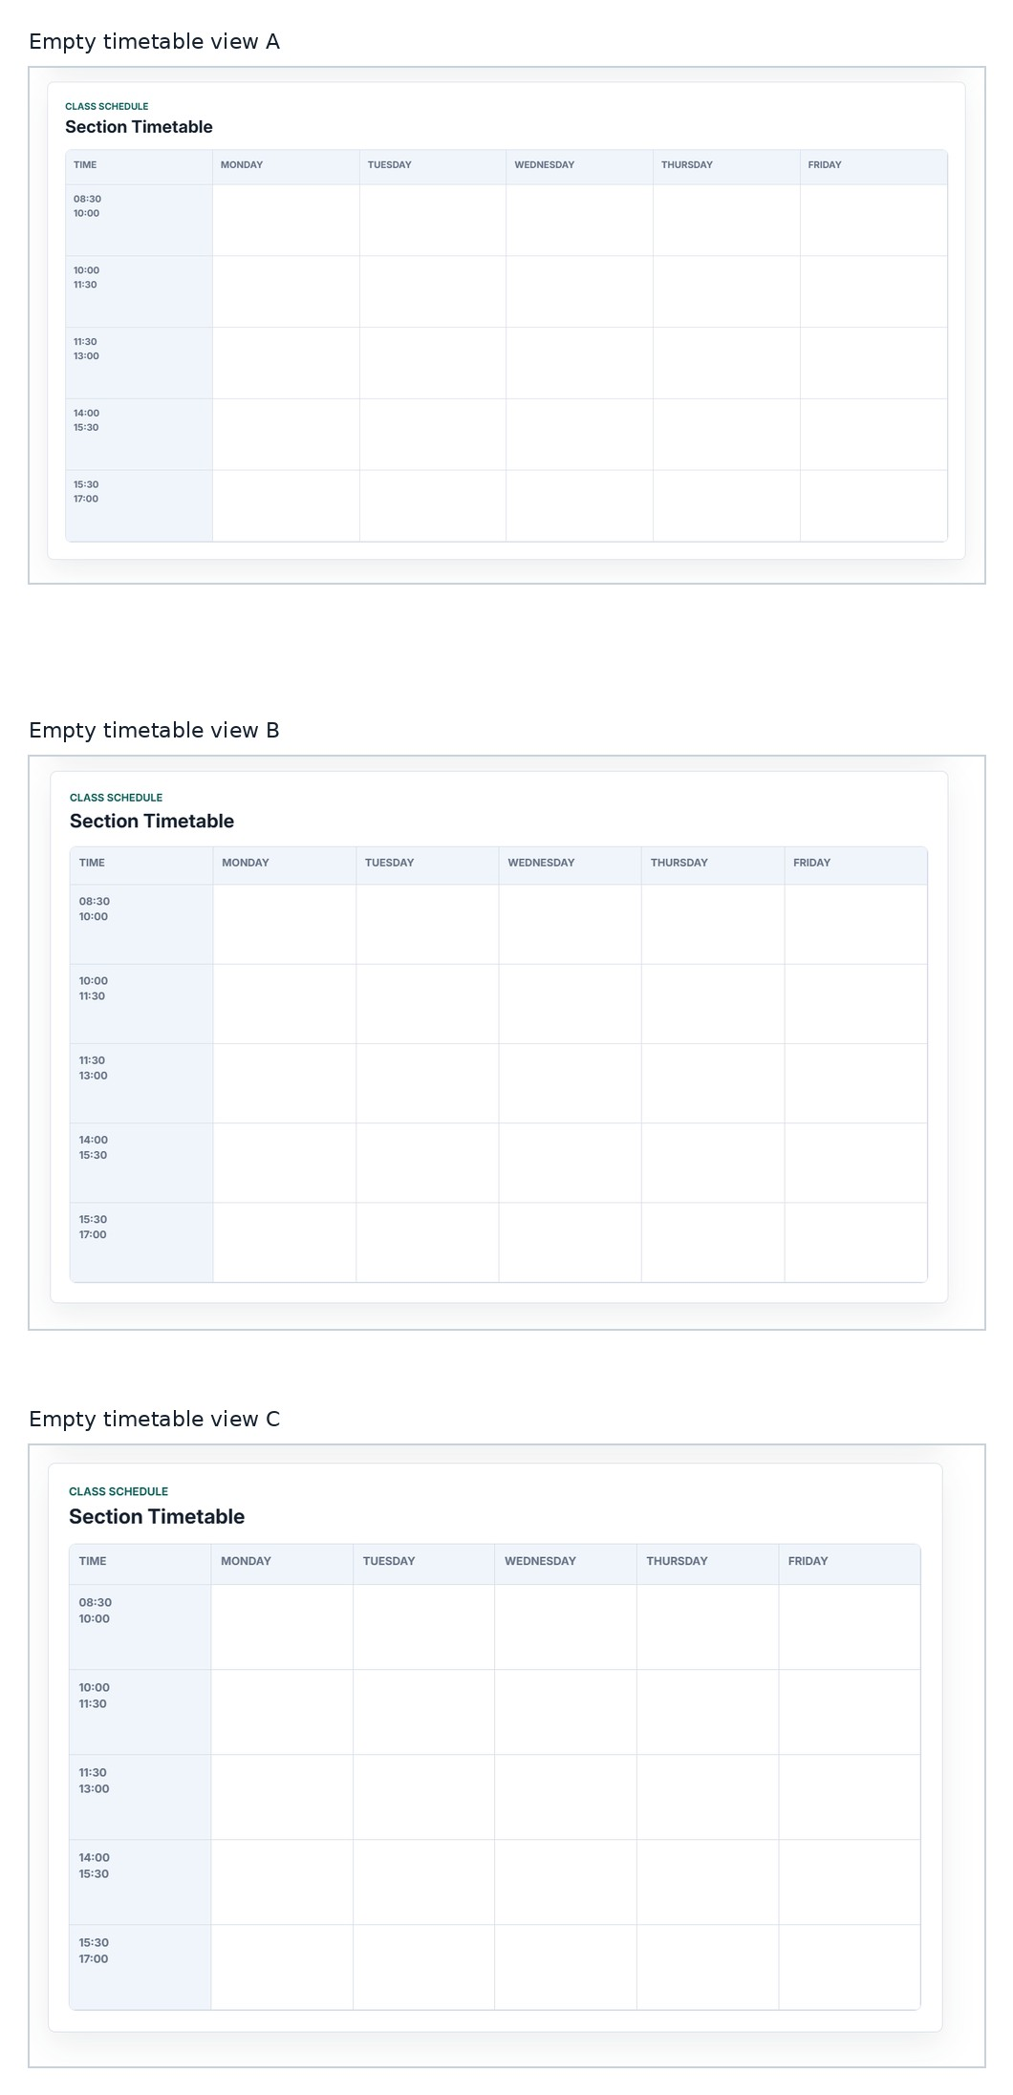
Figure 10.4 - Empty timetable grid states before generation or before entries are loaded.
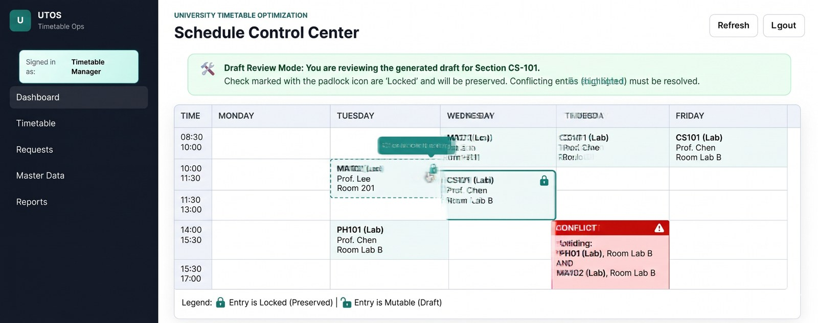
Figure 10.5 - Draft review mode showing locked entries, mutable entries, and conflict highlighting.
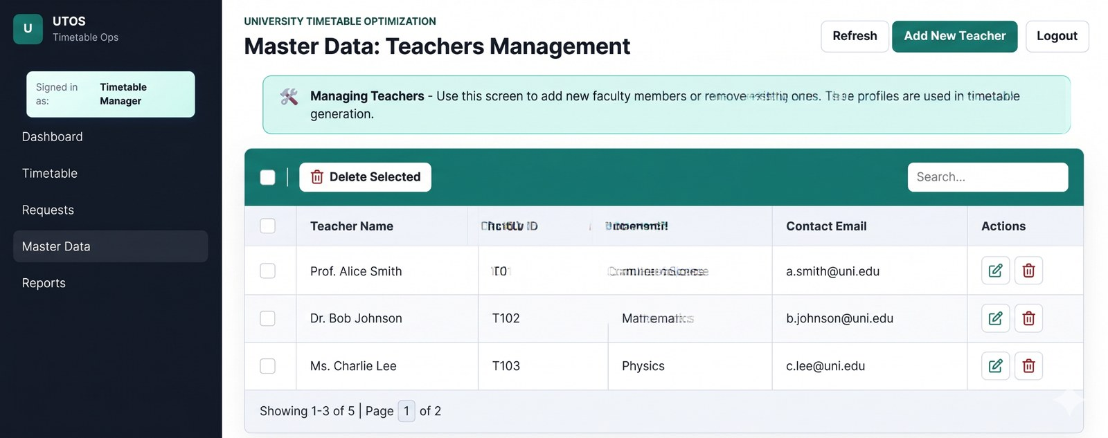
Figure 10.6 - Master Data: Teachers Management screen.
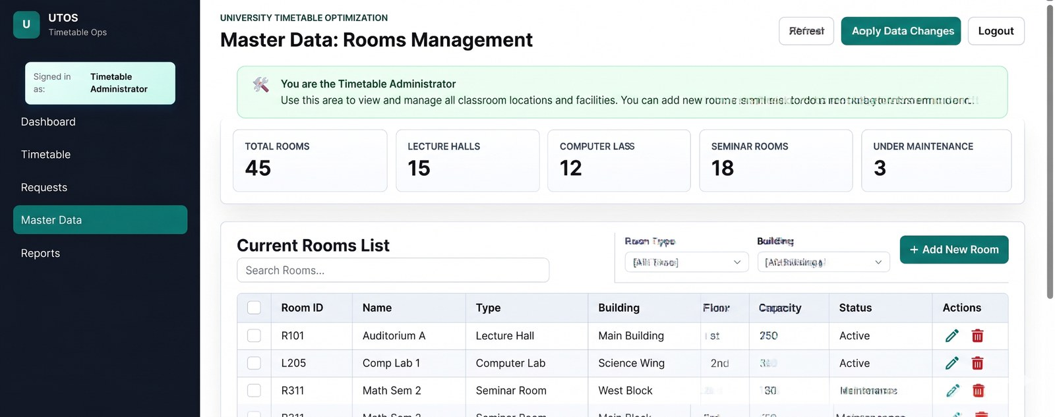
Figure 10.7 - Master Data: Rooms Management screen.
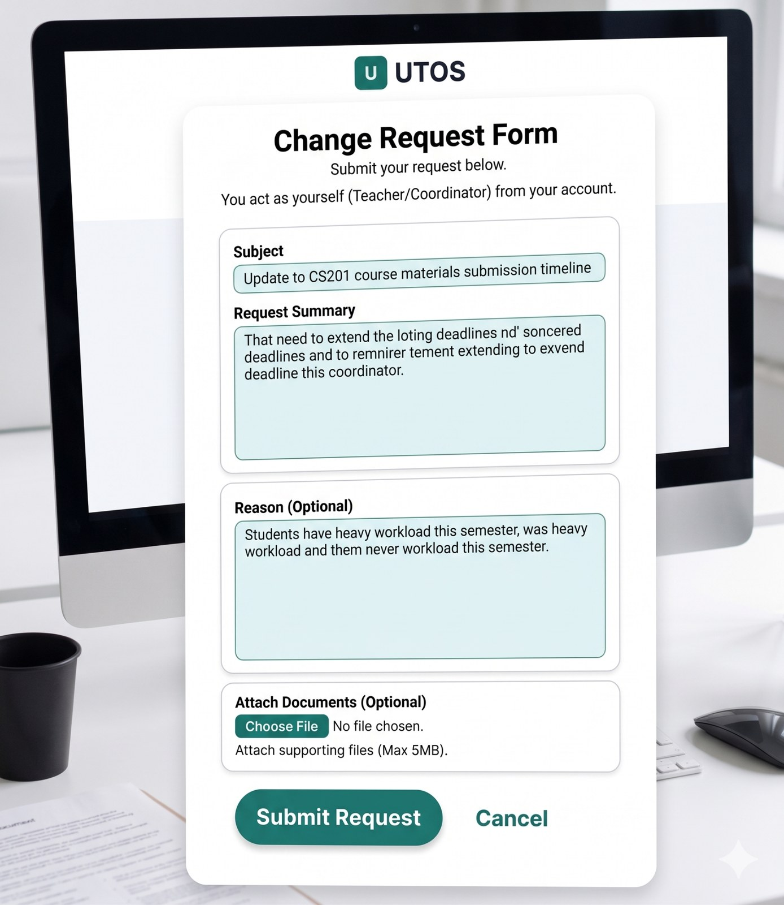
Figure 10.8 - Change Request Form for teacher/coordinator request submission.
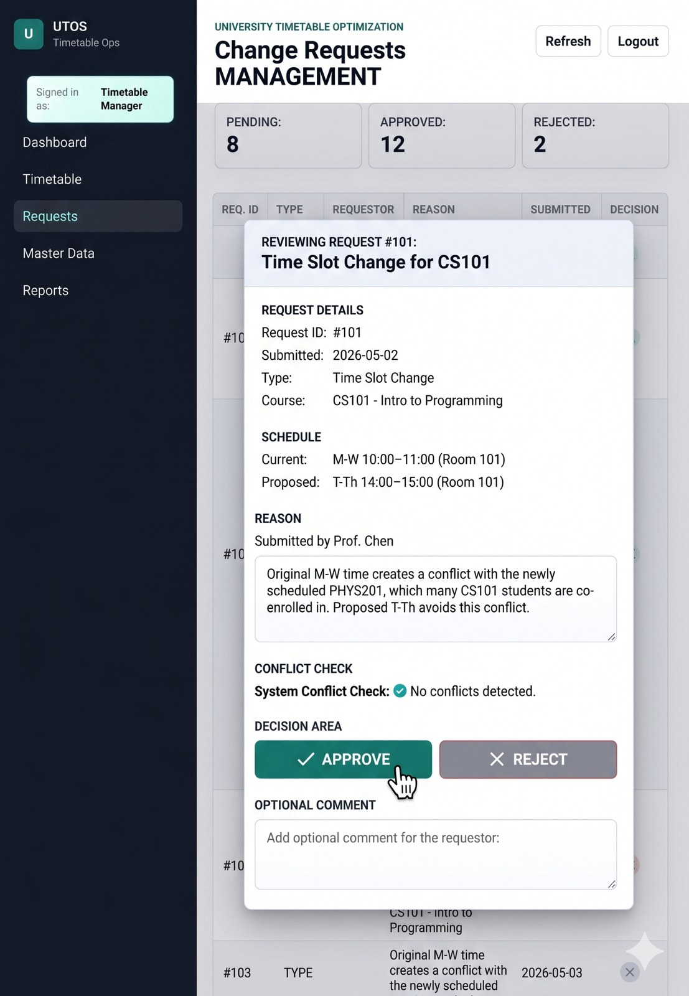
Figure 10.9 - Change Request Management review modal with approve/reject decision area.
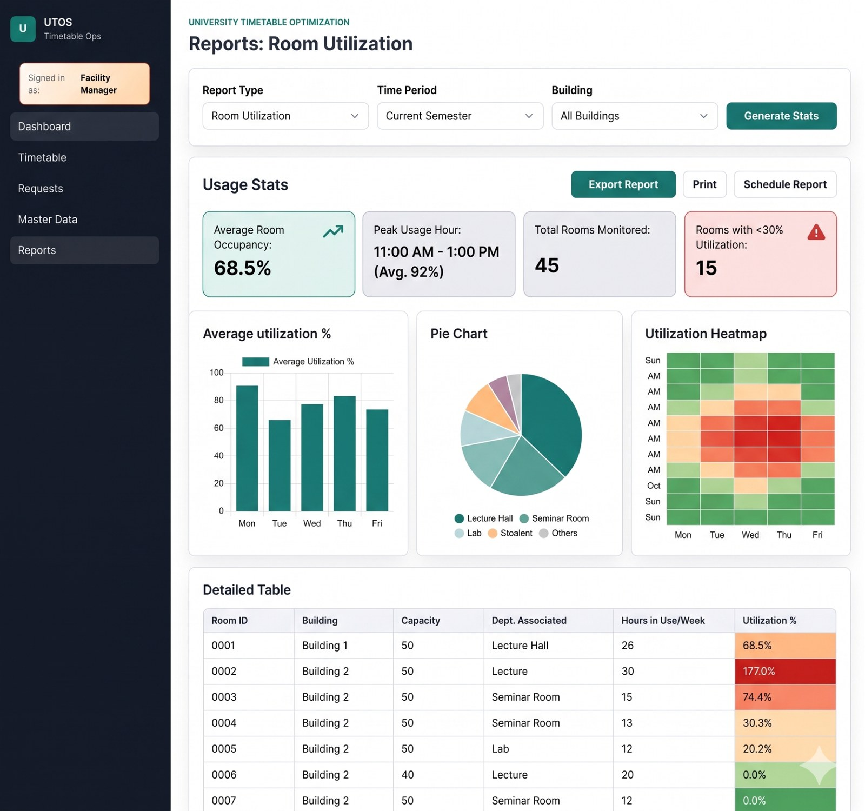
Figure 10.10 - Room utilization report with stats, charts, heatmap, and detailed table.
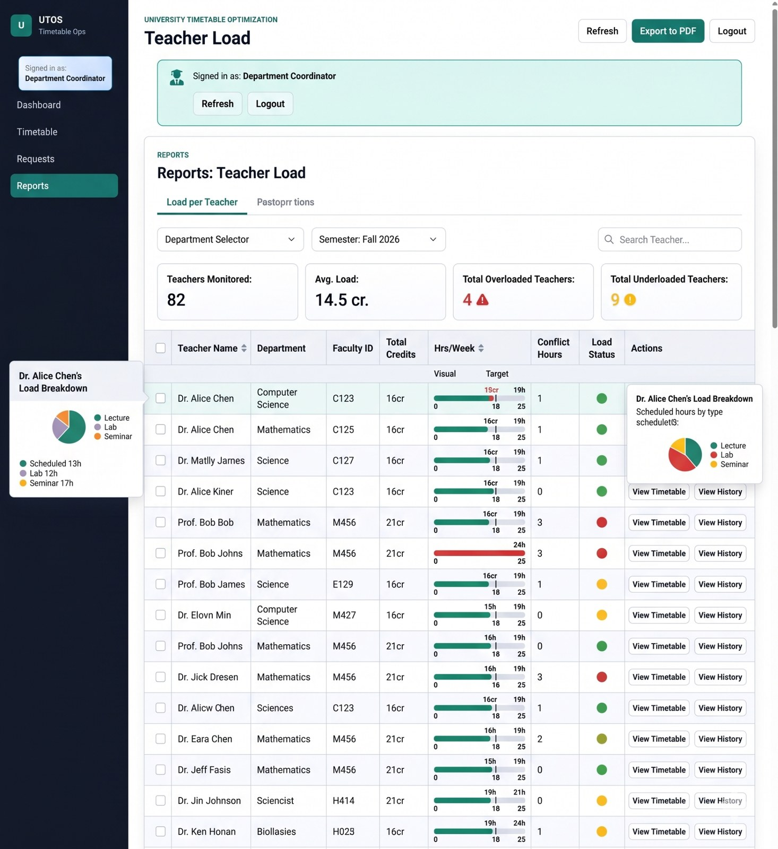
Figure 10.11 - Teacher load report with load status and per-teacher breakdown.
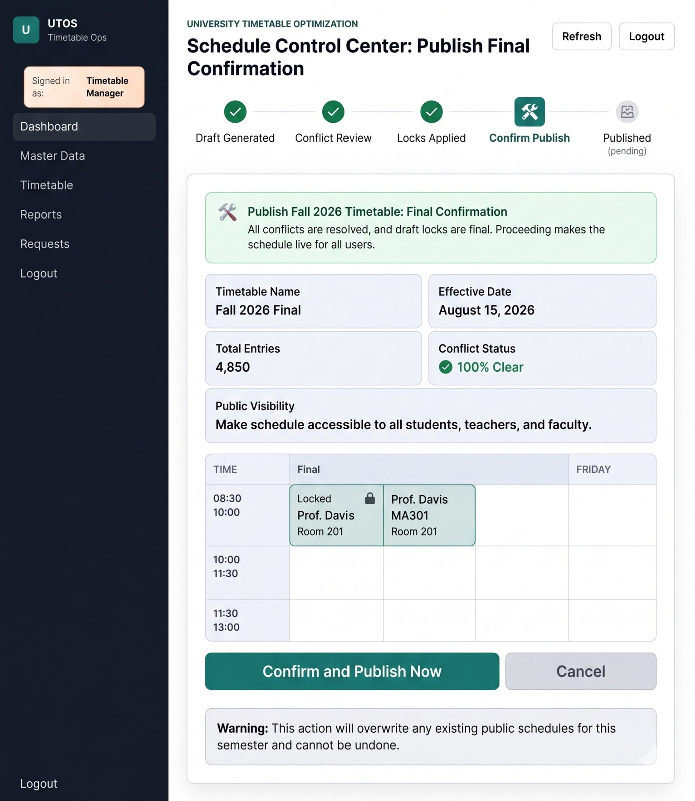
Figure 10.12 - Publish final confirmation screen with conflict status and warning.

11. Final Modeling Notes and Conclusion
- The new use case set is aligned with SRS v1.0 rather than the earlier class-only scope.
- Essential and real use cases are separated so the analysis remains academically correct while still connecting to current UI screenshots.
- Use case diagrams are split into class-timetabling and exam/system-wide views to avoid overcrowding.
- The ERD is acceptable as a class-module baseline but must be extended for full-scope versioning, notifications, audits, student hierarchy, and exam sessions.
- The swimlane, DFDs, sequence diagram, and architecture flow are generally correct and now have clearer explanations tied to the use cases.
- The UI screenshots provide evidence that the major real use cases already have interface support: login, dashboard, generation/review, change requests, master data, reports, and publishing.
Conclusion: The improved document now presents UTOS as a full-scope university timetable optimization and management platform. It preserves the original class timetable core, but adds the system-wide and exam-timetable features required by SRS v1.0. The use case section now follows the teacher-provided analysis-model guidance by including high-level use cases, expanded use cases, essential and real flows, typical courses of events, and alternative courses.

